Lab 3

14. Electric Potential Fields

Andrea Tuggle

05/02/2019

Physics II

Dr. Harrison

1. OBJECTIVE

This lab will help us understand potential energies and electric fields affected by point charges in the presence of fields. We will be using Sage Math to represent this as well.

1. THEORY

We are expected to use Sage Math and understand how when electric potential and electric fields are affected by the location of point charges.

Points of Interest/ Variables: Formulas:

V= (kq­1)/r1

V= (kq2)/r2

E= (kq1)/ (r1)2

E= (kq2)/ (r2)2

A2 + b2 = c2

* Charge 1= Q1
* Charge 2= Q2
* Coordinates= x1,x2,y1,y2
* E= electric field
* K= Coulomb’s law constant
* V= electric potential

1. PROCEDURE

1. Consider placing two point charges on an x-y plane, the first charge, q1, at (x1, y1), and the second charge, q2, at (x2, y2).

2. Derive an expression for the electric potential and field at any arbitrary point (x, y) in terms of q1, q2, x1, x2, y1 and y2.

3. Choose some reasonable values for q1, q2, x1, x2, y1 and y2 and make a rough sketch of what you expect the electric potential/field to look like. Your picture doesn’t necessarily have to be correct, but you should include some justification for why your sketch looks the way it does.

4. Use Sage Math to draw the exact electric potential and field using the expression derived above.

Following the given instructions above, I did my calculations by hand/used given code for Sage Math/made a rough sketch and then plugged my data into Sage Math to create an electric field.

1. DATA

Given code:

x, y = var("x y") g = Graphics() g += contour_plot(1.5 + 0.2*x*y, (x, -4, 4), (y, -4, 4), fill=False, cmap=’jet’, labels=True, contours=[0, 1, 2, 3, 4], label_fontsize=14) g += plot_vector_field((y/2, -x/2) , (x, -4, 4), (y, -4, 4)) g.show()

1. CALCULATIONS

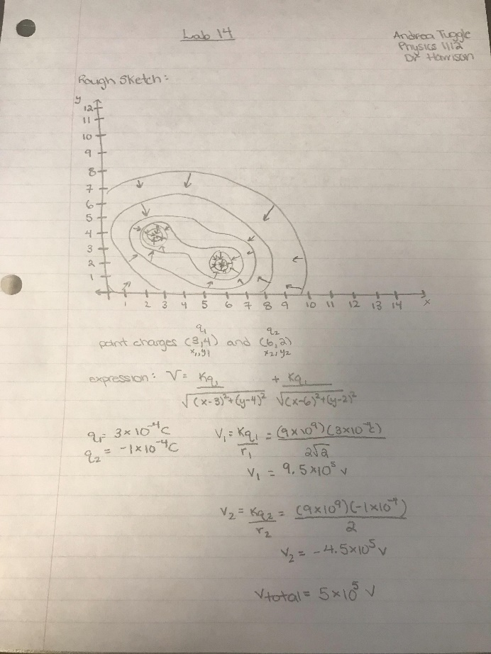

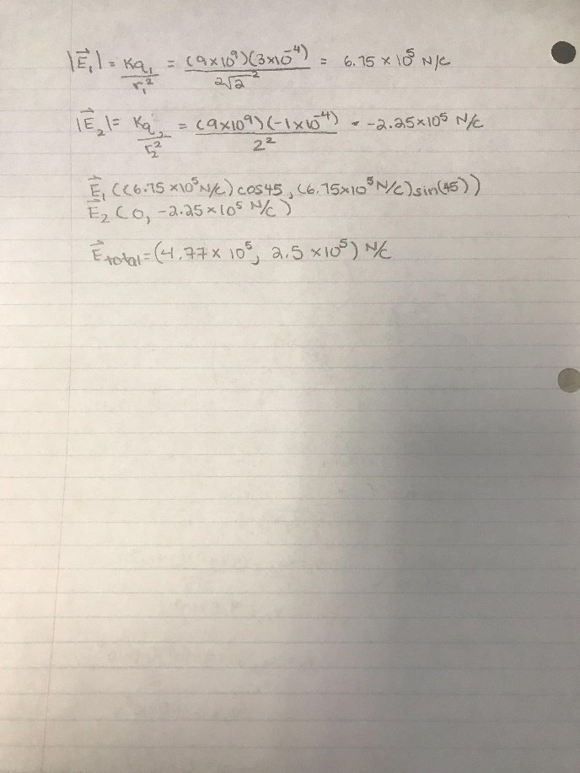

1. RESULTS

When I plugged in the original code given the result was the graph listed below.

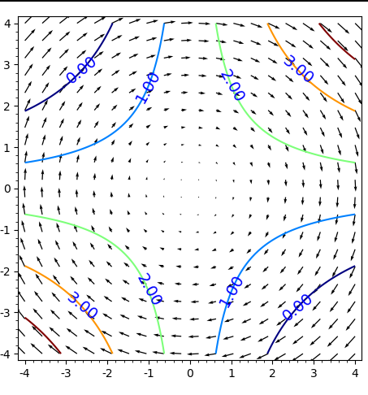  
After playing with the Sage Math software this was my result below.

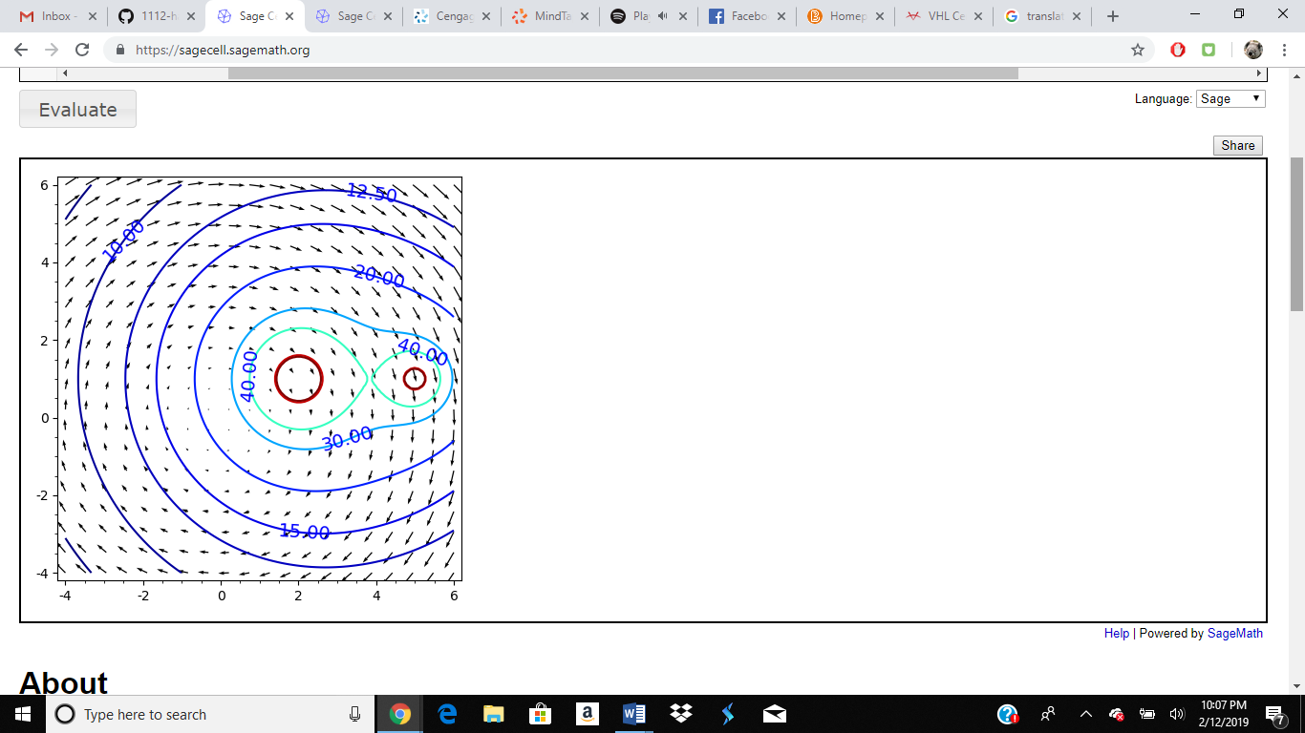

Part 2: Electric Field Hockey (I promise the all said goal before I used the snipping tool- the particles are in all the goals)

Level 1:

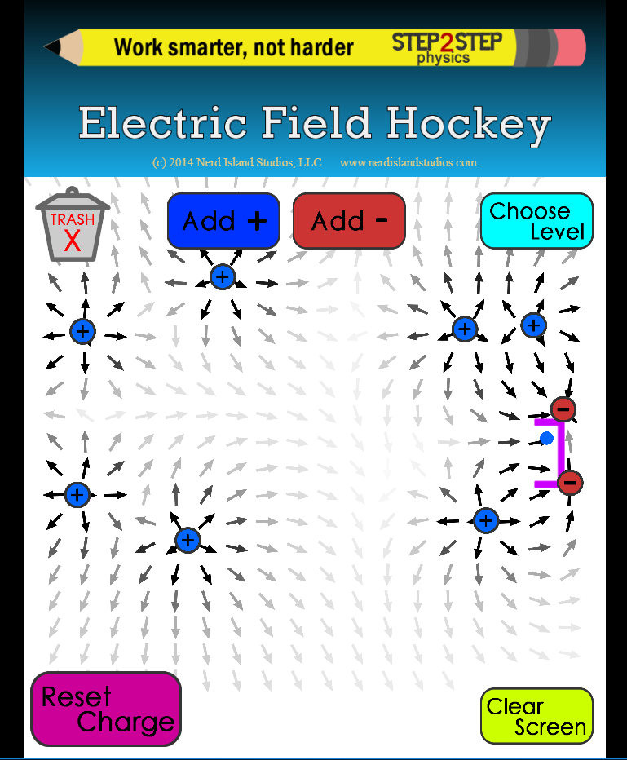

Level 2:

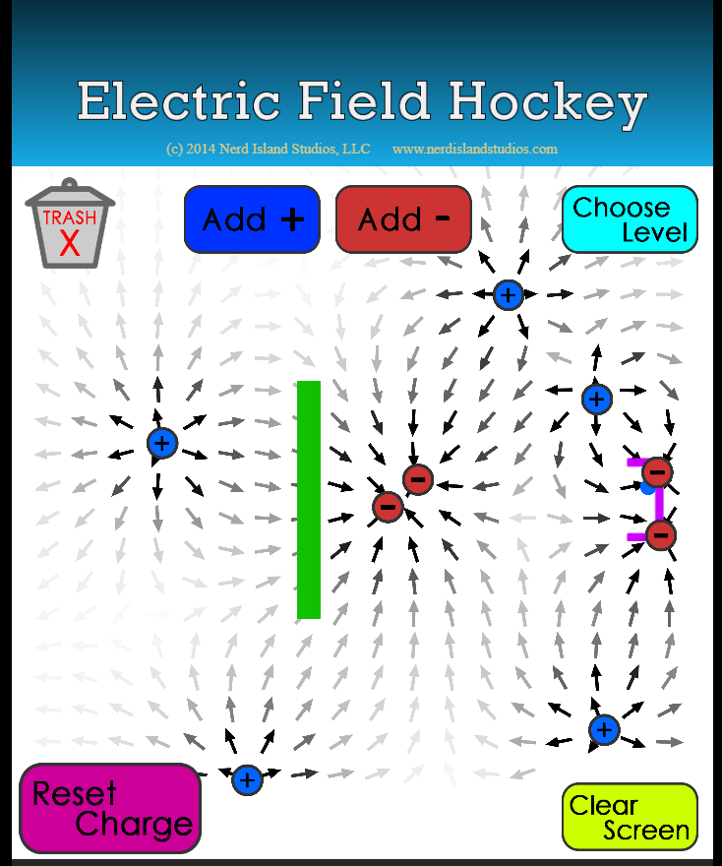

Level 3:

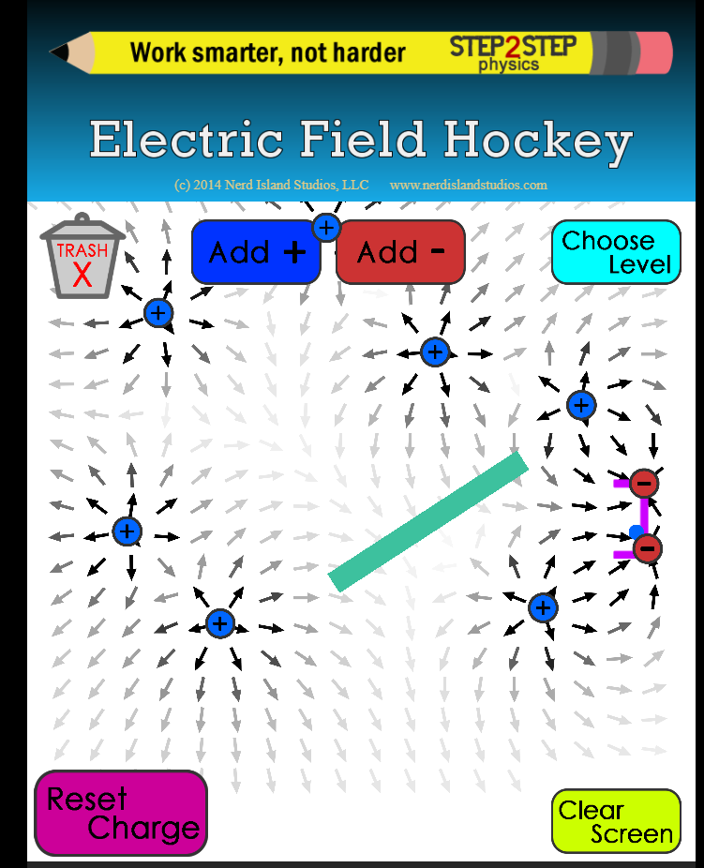

Level 5:

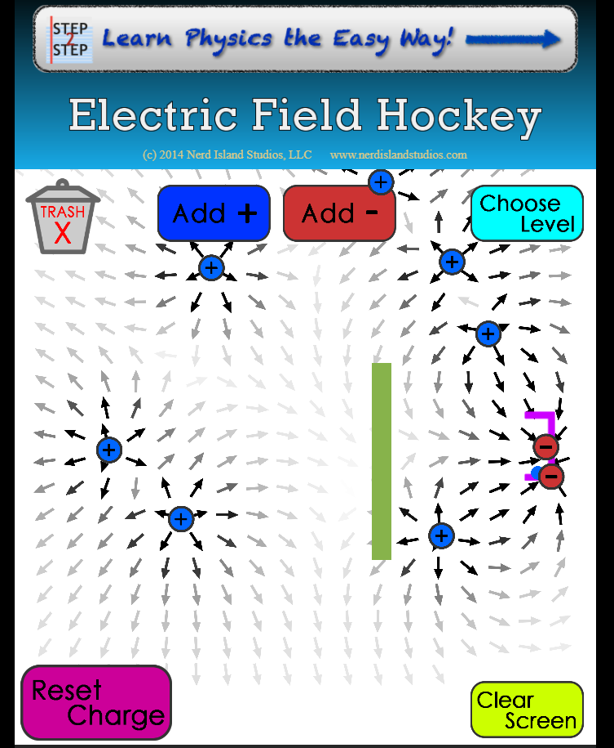

1. ANALYSIS

Overall, I learned how the location of point charges/electric fields effect one another’s position and movement.

1. COMMENTS

To this day, I unfortunately still don’t understand Sage Math that well, but I’m grateful for the eye opening.